36.27: a) Find 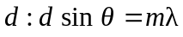
The number of slits per cm is 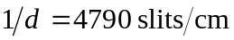
b) 1st order:
2nd order:
c) For 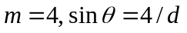 is greater than 1.00, so there is no 4th-order bright band.

